# Required Training Reports

Principals and non-school supervisors can generate their own compliance report via **Advanced Reporting** in ELMS in order to identify employees who have not completed the CCSD required training. These instructions are universal all compliance training, including the reports for the District’s yearly mandatory eLearning, the Covid-19 training compliance report, and the test security administration training report.

To view the reports, follow these steps.

1. Log into ELMS at [**learn.ccsd.net**](https://ccsd.sumtotal.host) using your standard user ID and password.

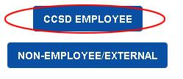

2. Once logged in, click the **Self** icon in the menu bar to show the drop down menu.

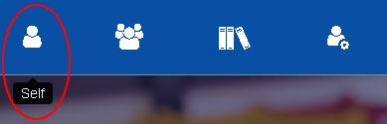

3. Find **Reporting** in the list, and click on it to open a sub menu.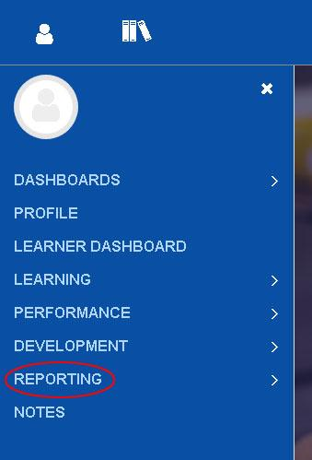

4. Click on **Advanced Reporting** to be taken to the Advanced Reporting Area. Please be patient as the Advanced Reporting area of ELMS is sometimes slow to load during peak usage hours. If it is loading slowly, trying clicking on Advanced Reporting again to re-load that area of the site. If it seems like Advanced Reporting is not loading at all, you may also try logging into ELMS with a different web browser.

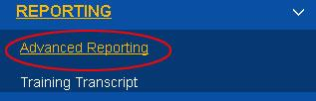

5. After selecting Advanced Reporting, under Repository, expand Custom>Reports and select Administrator to view all available reports.

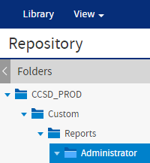

6. From here Site Administrators can choose which report they would like to run. Yearly mandatory eLearning reports are **CCSD Required Training Site Completions Report** andthe **CCSD Required Training Not Completed Report.**  **CCSD Required Training Not Completed Report** will be released in October and will show supervised employees at that site who have not yet completed the required training. The **CCSD Required Training Site Completions Report** will show the completion status for CCSD required training for all staff at the site, both completed and not completed.

For Covid-19 mandatory training, the report is named **Covid-19 School and Department Compliance Training Status Not Completed Report.**

The Test Security Administration Compliance report will be updated after the training is released for all employees for the 2022-2023 school year.

7. Once you have selected the compliance report you want to run, you will need to select your location for the report to run and display your staff compliance information. Click the **“Options”** button to bring up the locations menu.

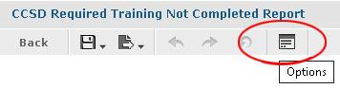

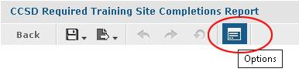

8. In the Options menu, search for your location’s name by clicking on search list under the “Available” tab.

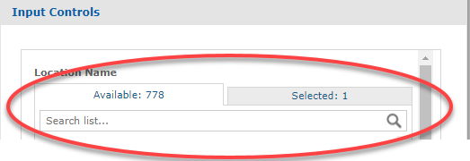

9. Find your location name by scrolling alphabetically in the list or use the search box. Once you have found and clicked on your location to select it, click the OK button to run the report.

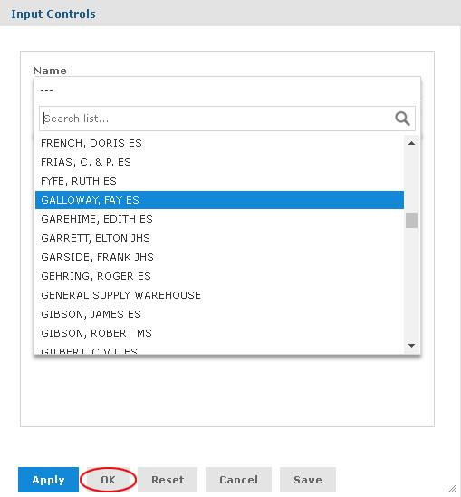

10. You may export your report to Excel for easy reference and use, by clicking the Export button, and selecting “xlxs” from the list.

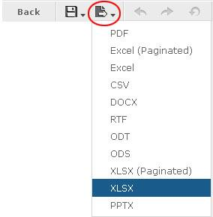

**Principals/Site Administrators who need technical assistance can submit a ticket via Quick-IT or by calling the Help Desk at (702) 799-3300.**